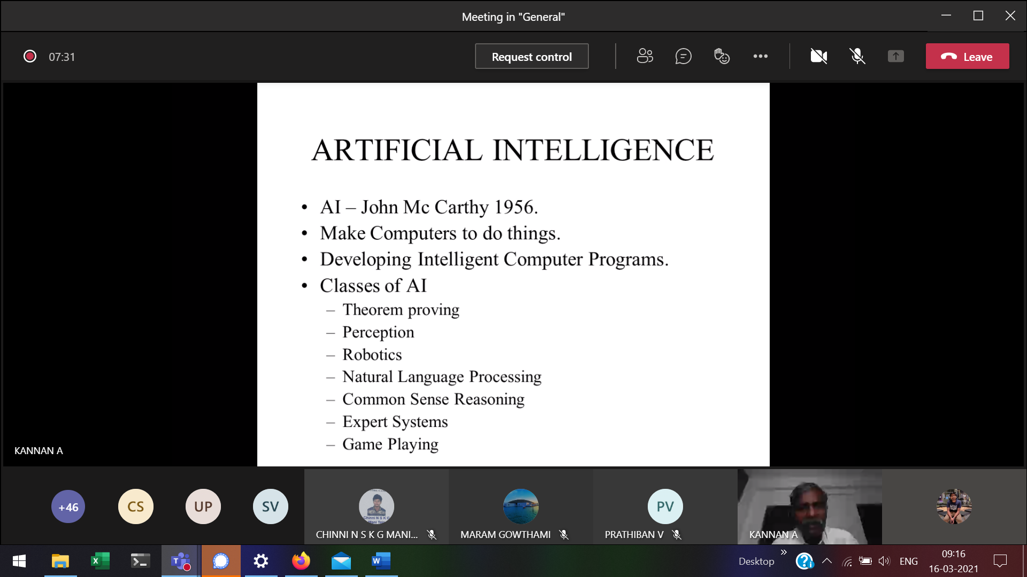Gaming system 🡪 Min Max problem (eg: cricket batting max(score), bowling min(score))

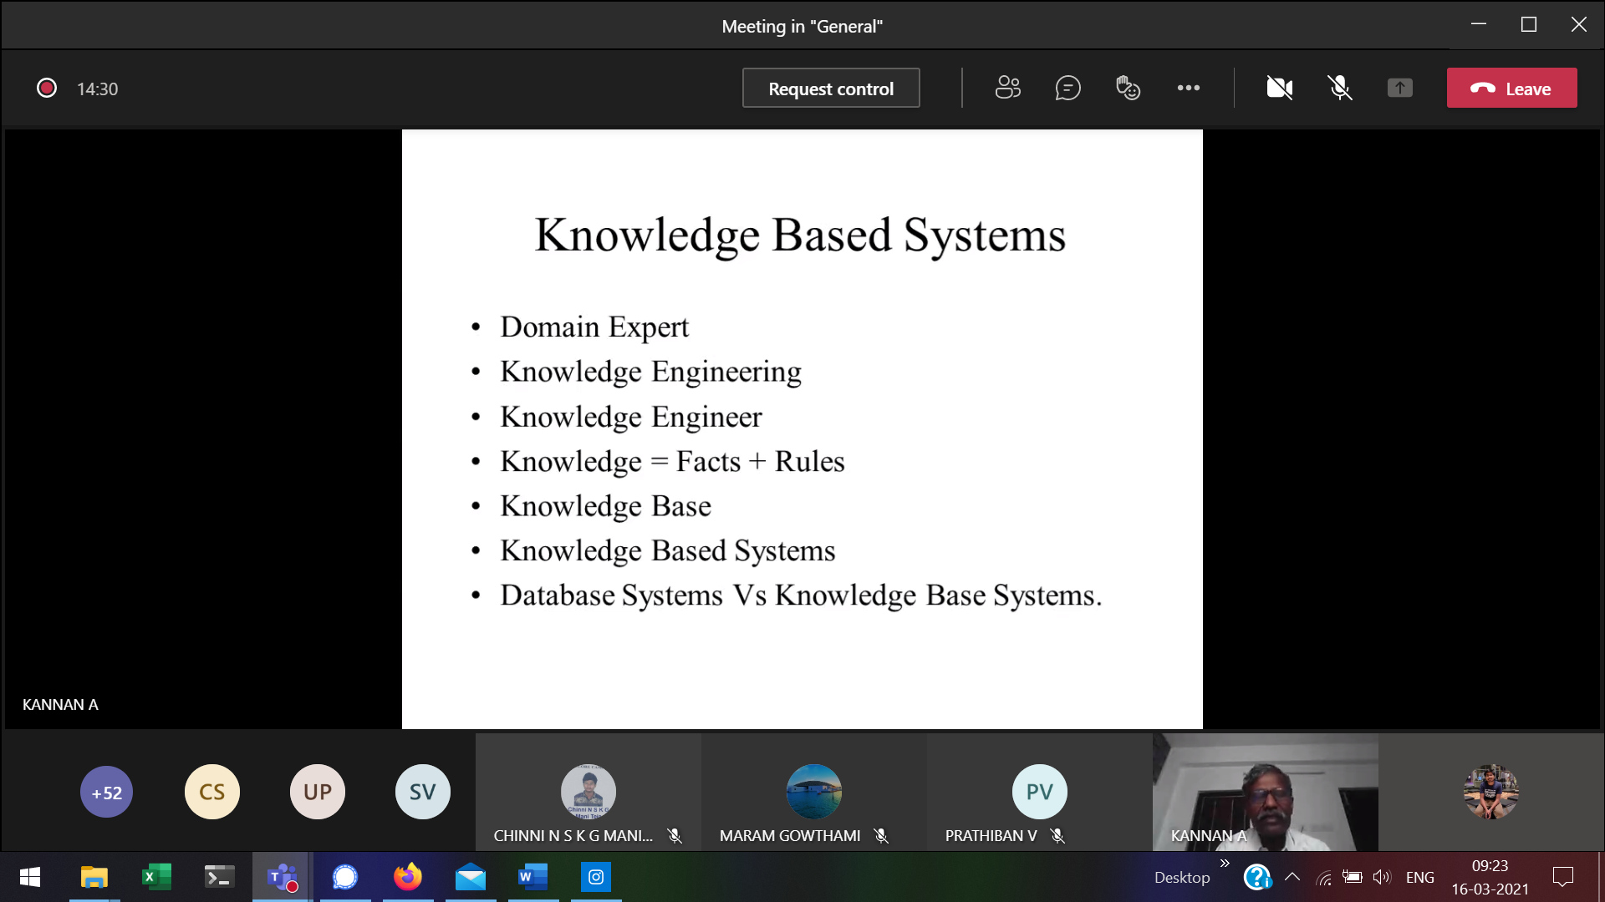

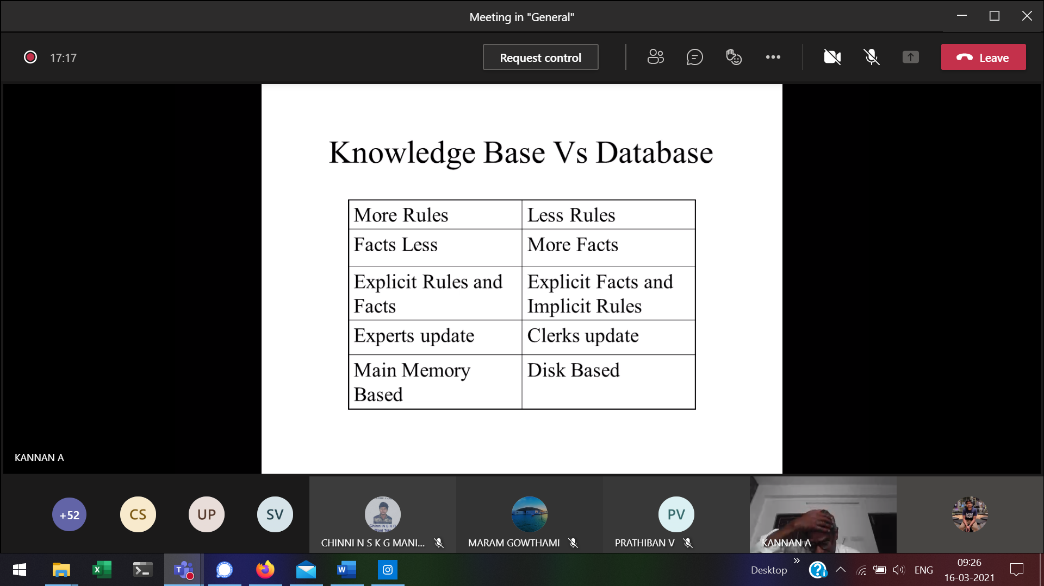

Data-base 🡪 Railway reservation systems  
Knowledge base 🡪 Chess game

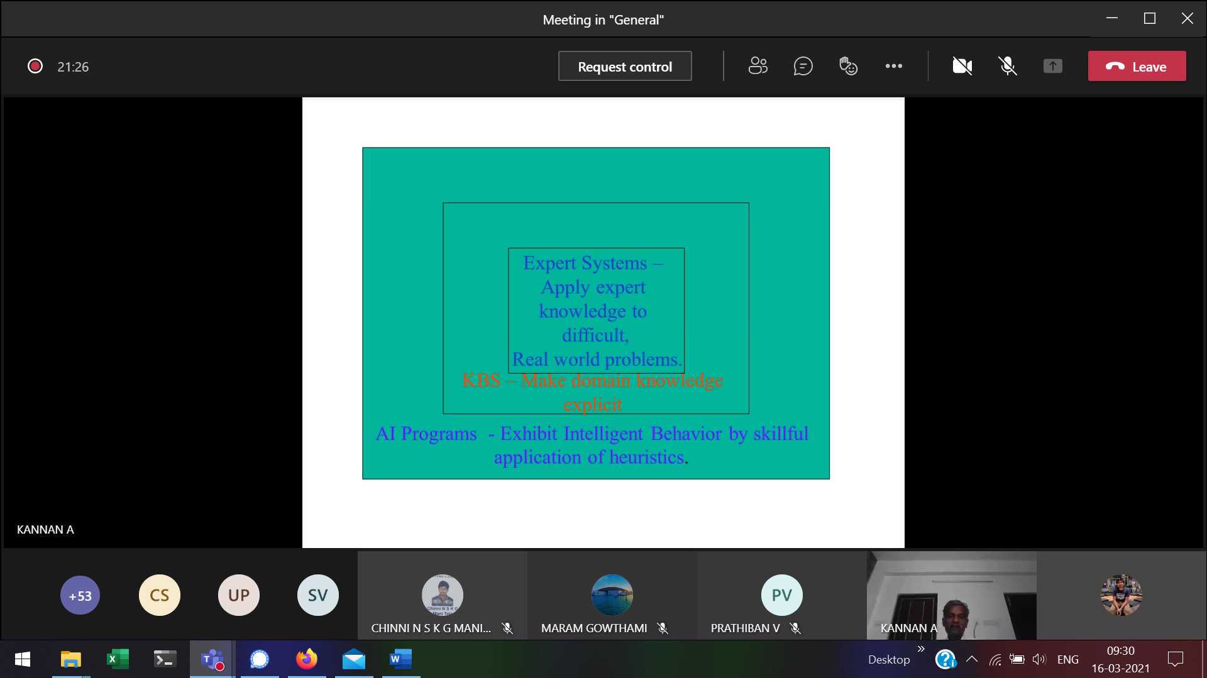

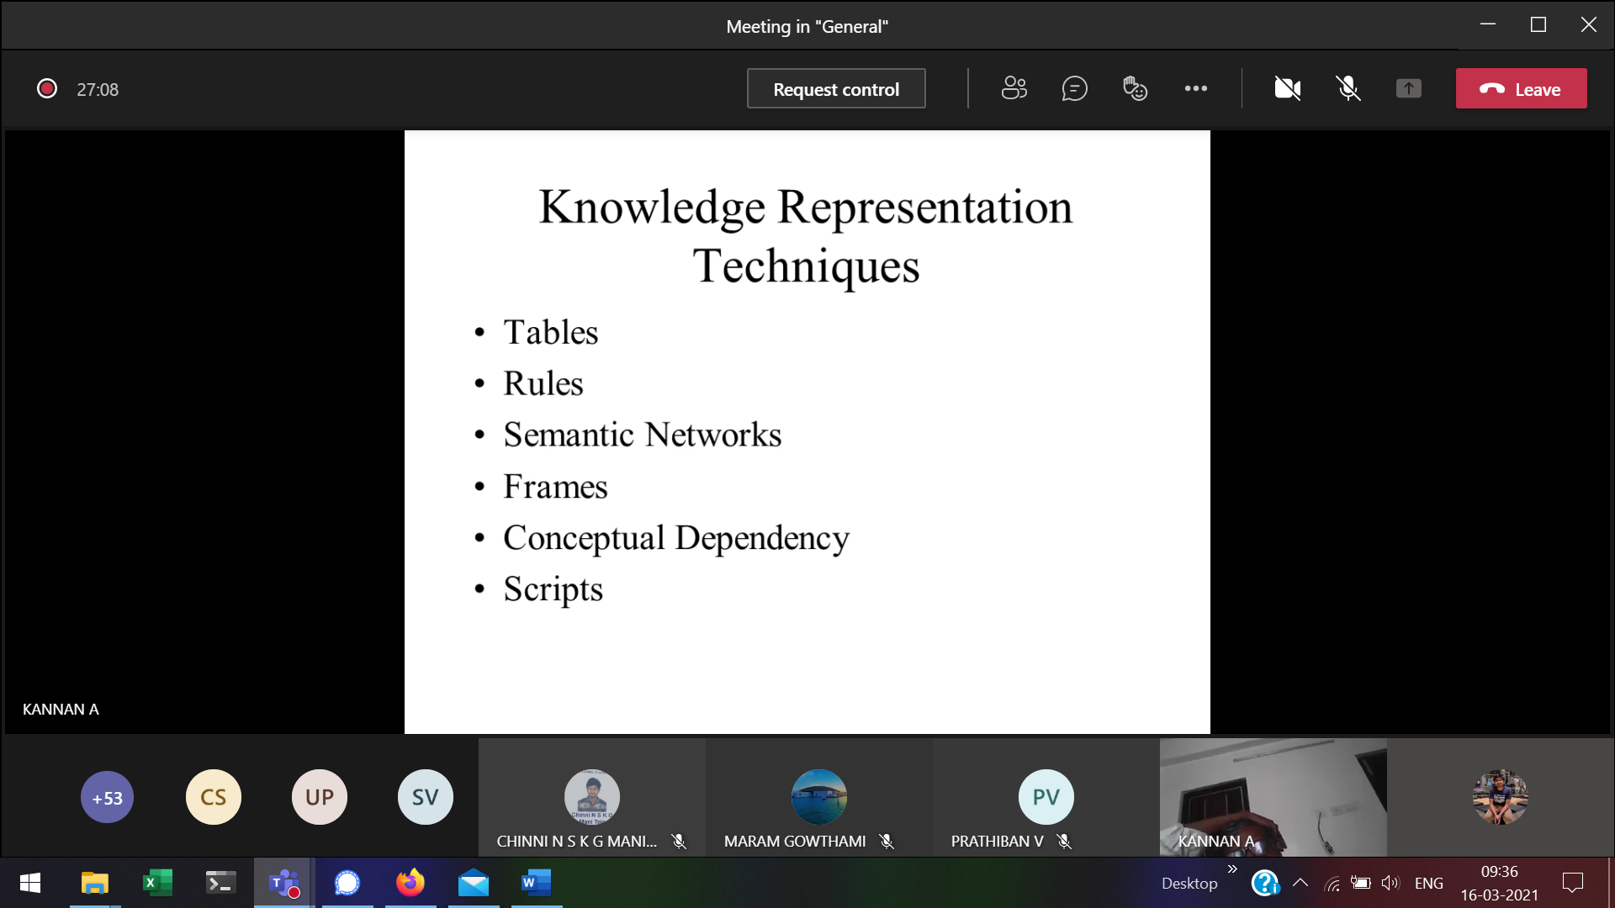

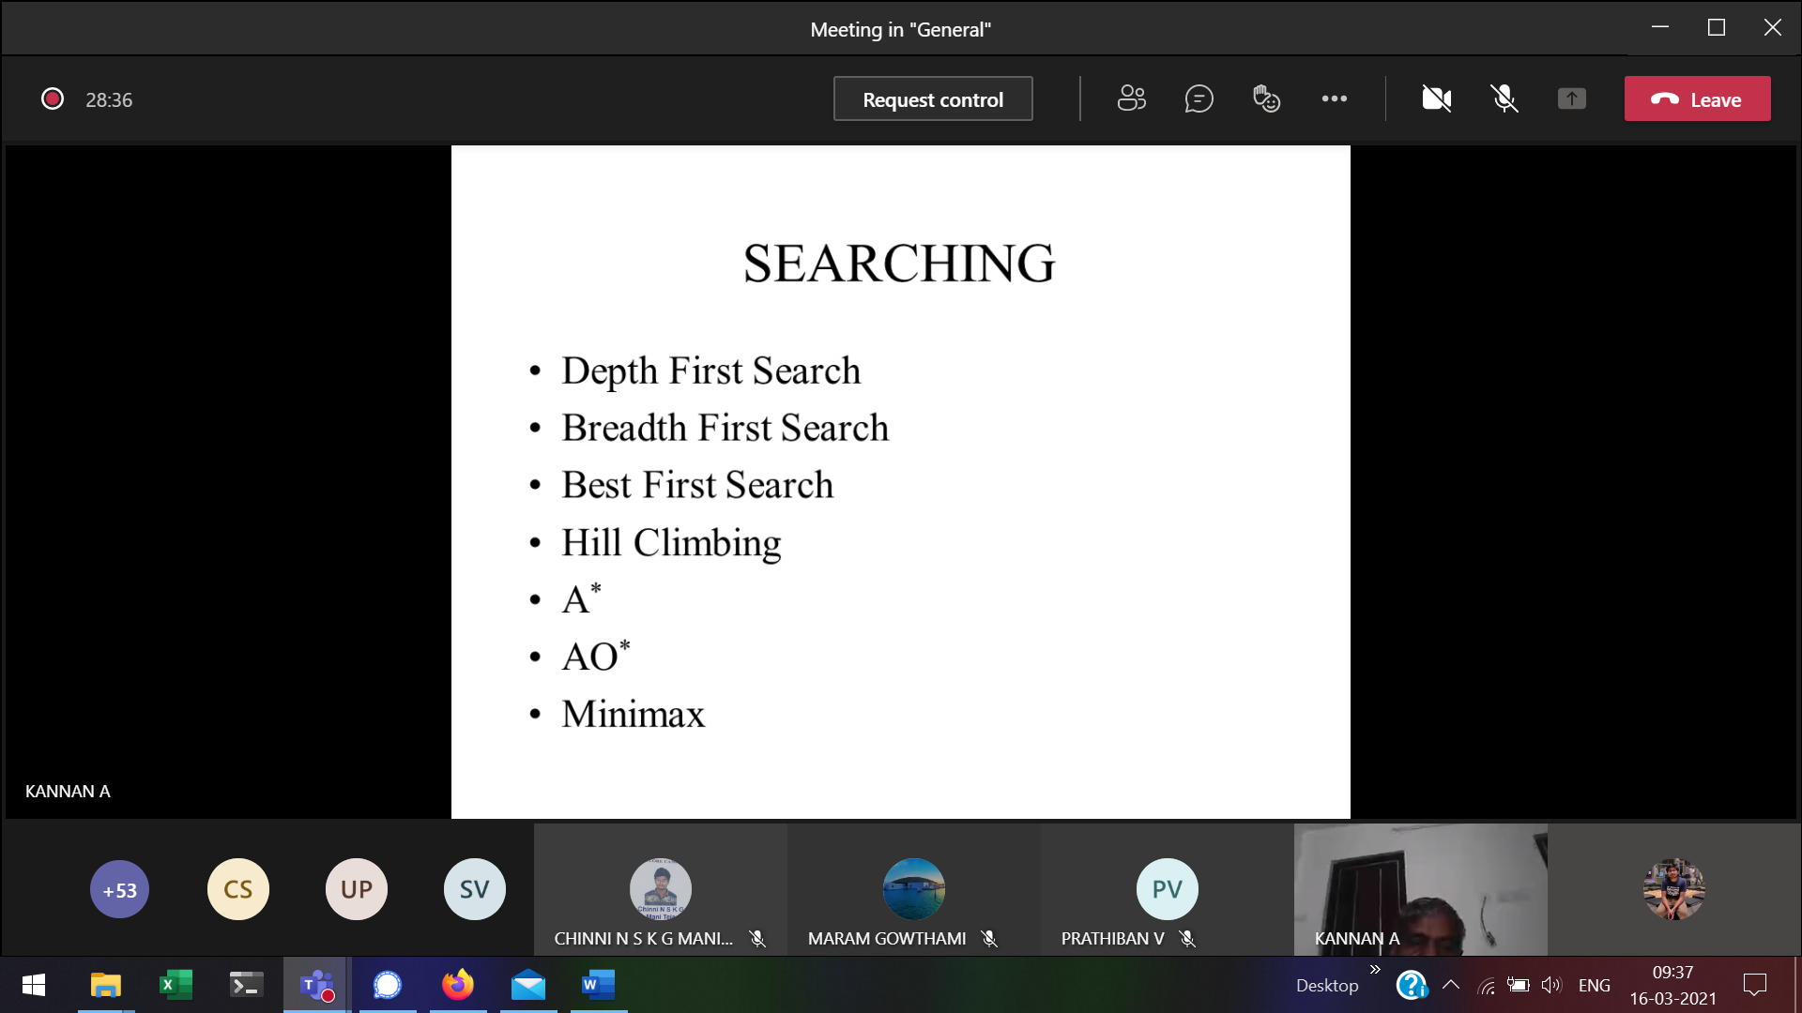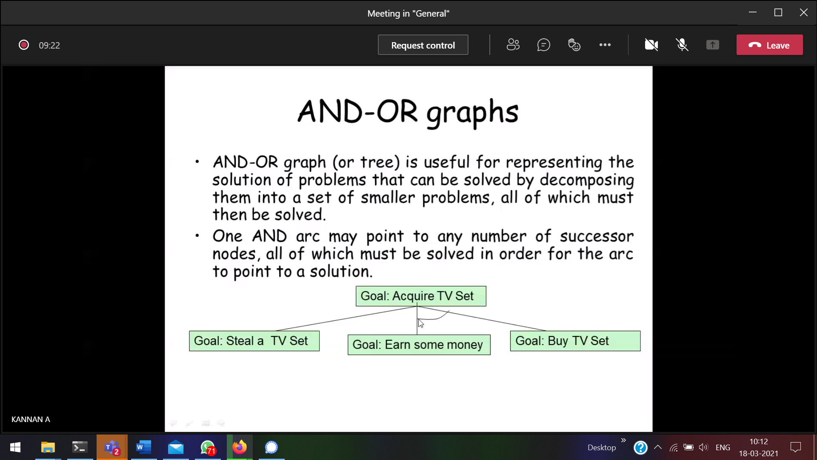

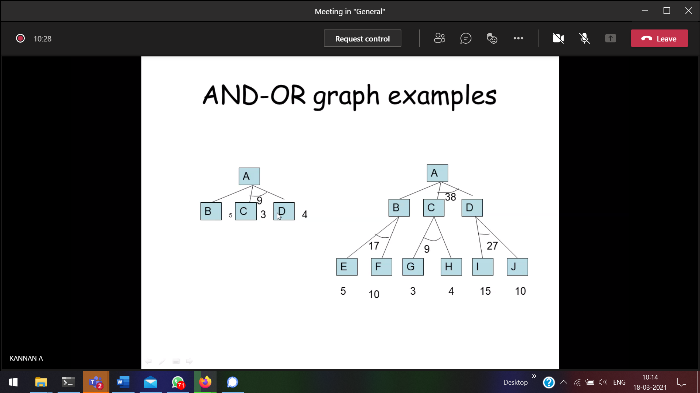



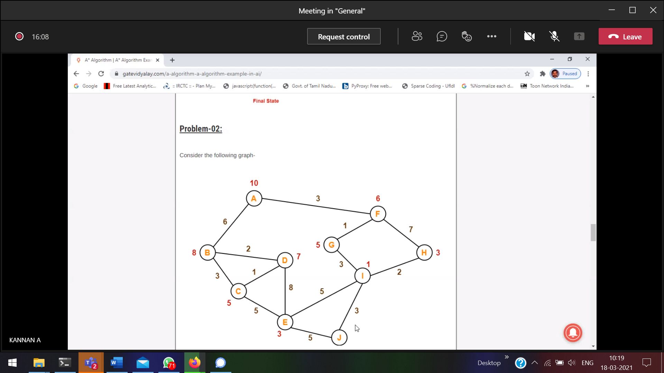



h(n) 🡪 Estimated cost 🡪 red colour value

AO \* algorithm

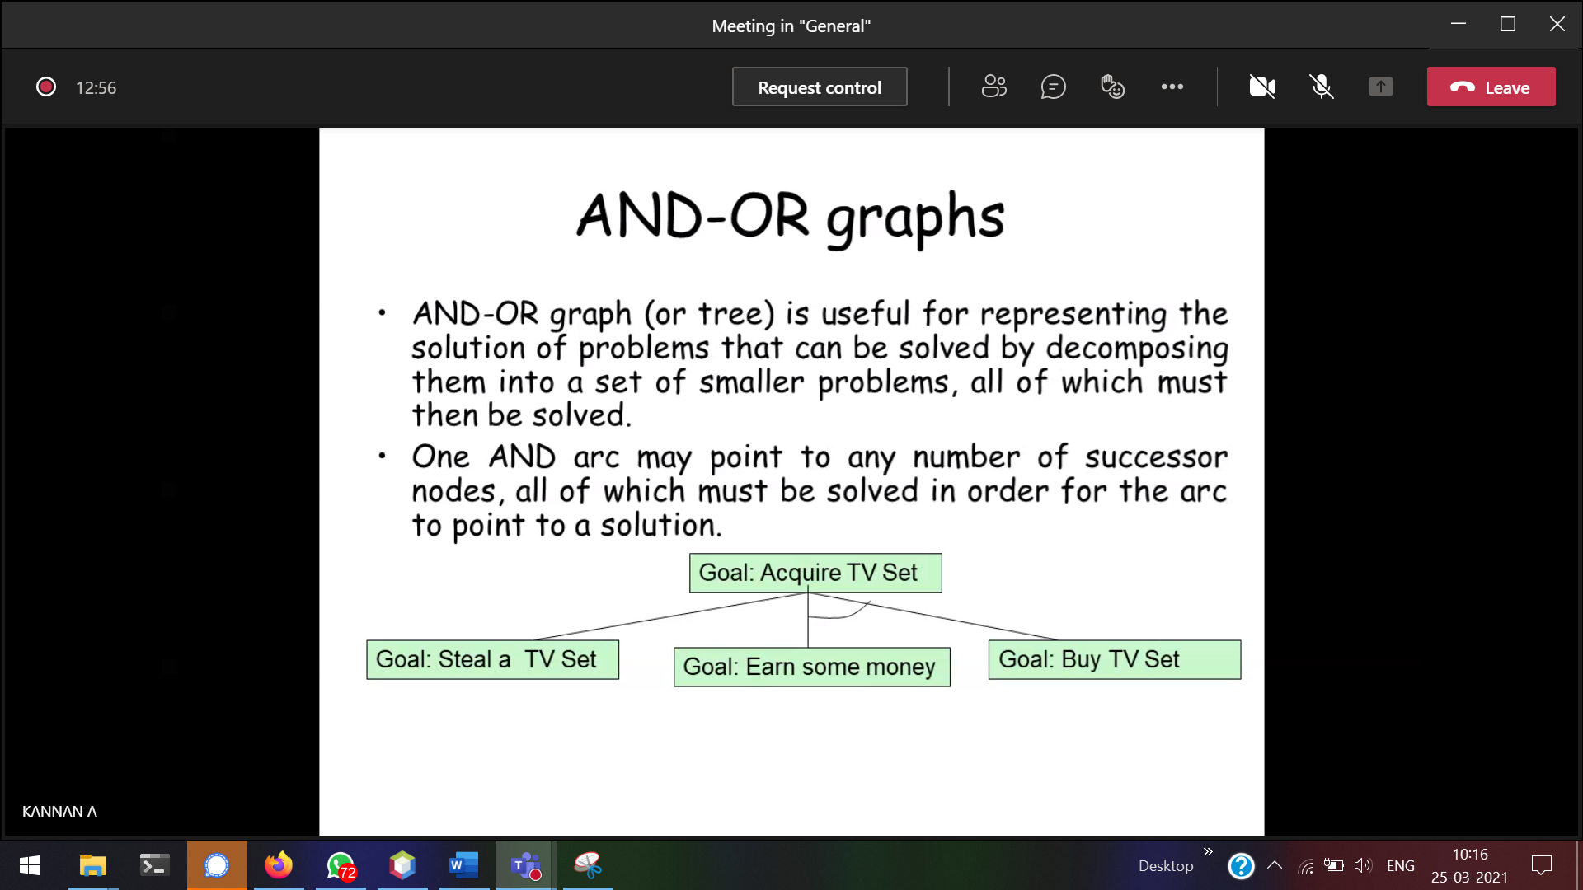

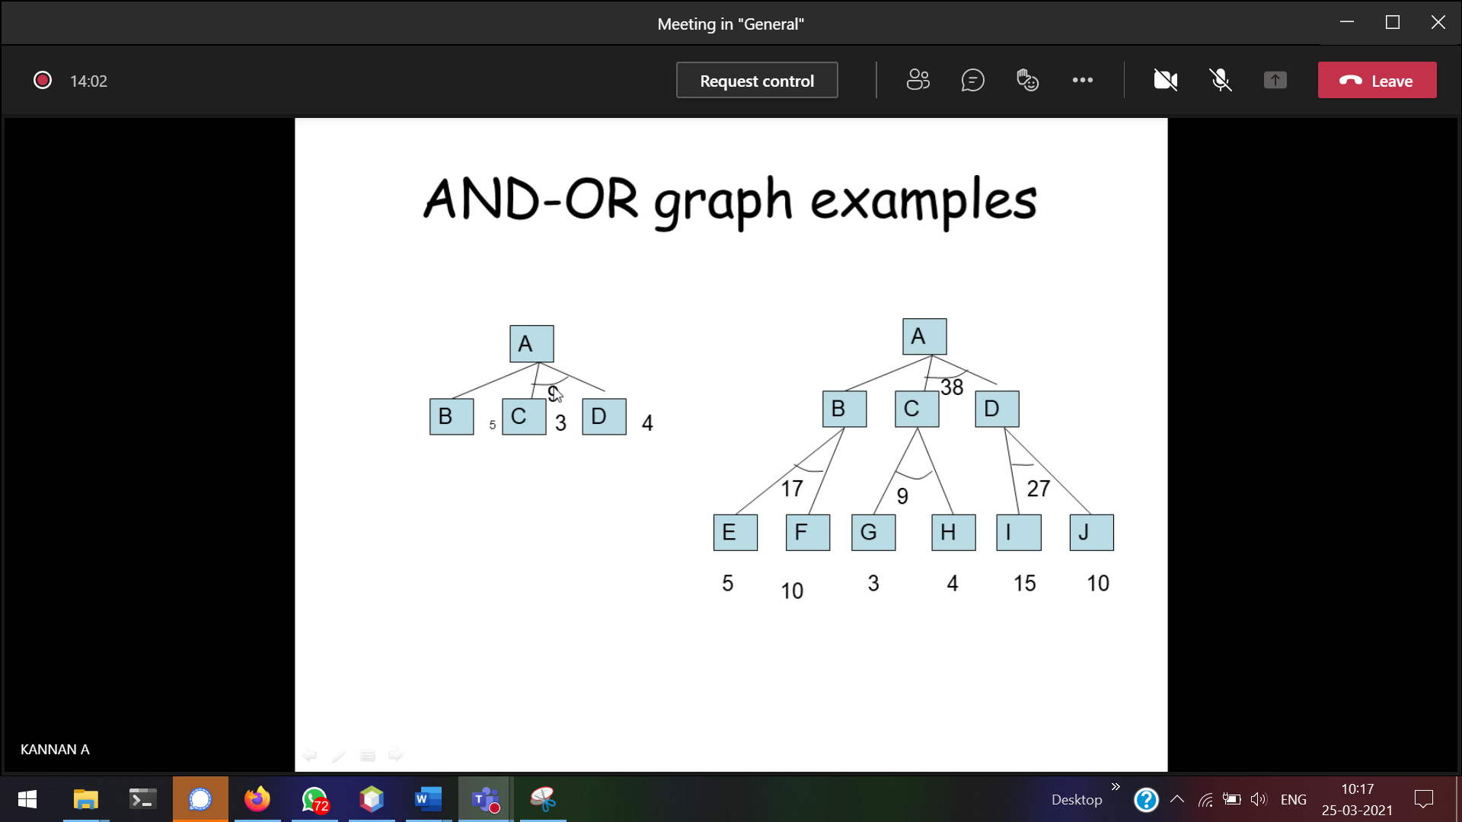



BEFB 🡪 1 + 5 + 10 + 1 🡪 17

C + D 🡪 36 , ACDA🡪 1 + 36 +1 🡪 38

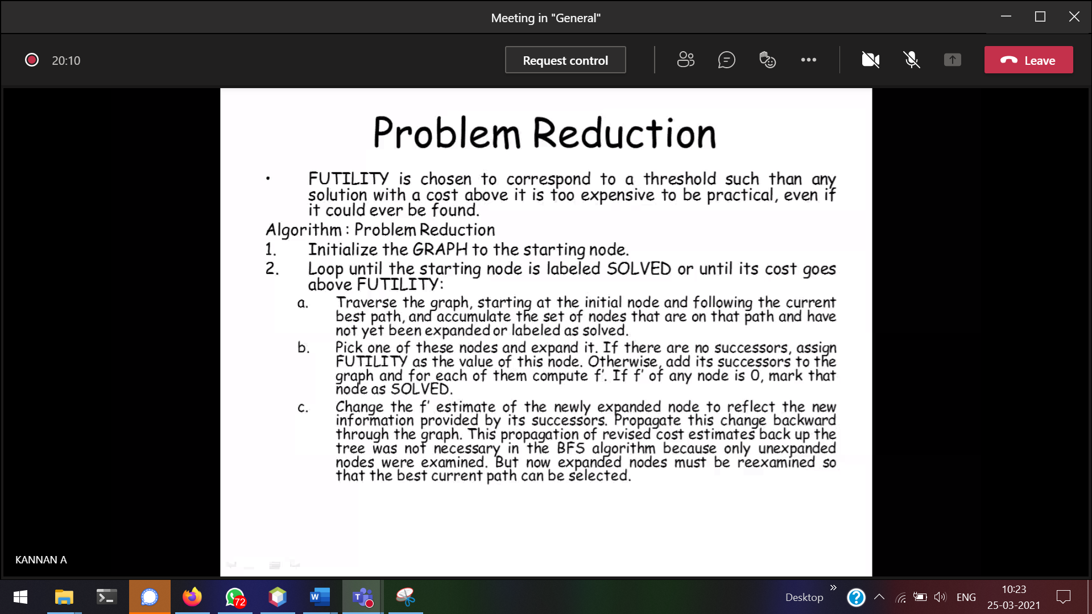

In A\*, two list is used.  
In Ao\*, only single list is used.

When the child is labelled solved, then the parent also becomes labelled solved.

